Sergio Araneda, Ph.D.
sondaxius@gmail.com

 | Ph.D., Research, Educational Measurement, and Psychometrics  University of Massachusetts Amherst 2019 - 2022
 | Mathematical Civil Engineer  Universidad de Chile 2005 – 2013  A mathematical civil engineer has 2 years in a common program with the rest of other engineering programs and 4 years of specific training in modern mathematics: Functional analysis, Measure theory, Partial Differential Equations, Stochastic processes, Optimization (linear, non-linear, discrete, optimal control), Discrete Mathematics, Numerical Methods, Information theory, and Statistics. It’s a strong program, one of the most prestigious programs in Applied Math in Latin America.

Work Experience (Murex Related, 3Y+)

Datamart Murex Consultant, CPQi; August 2018 – July 2019 (1 Y)  In-person Jersey City, NJ, US  Working as an external consultant for RBC (Royal Bank of Canada) in a Murex implementation project for Rates and their internal reports using the Datamart functionalities within Murex. The work required intensive SQL programming. | 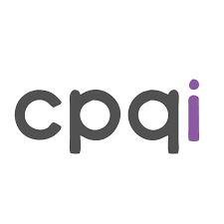
Back-Office Functional Consultant, Murex; September 2014 – February 2017 (2 Y 6 M)  In-person Santiago, Chile  Murex is a French software company that created the software MX.3, a platform financial institutions use to support the operation of financial products such as derivatives. My role on this job was to support clients in the Andean region on the functionalities related to the Back-office MX.3 provides. Most of my work was related to Post-trade workflow, Accounting, Confirmation documents, Settlement, Netting, pre-trade, and reporting (for Back-Office purposes). | 
Quantitative Analyst, Vision advisors; September 2013 – August 2014 (1 Y)  In-person Santiago, Chile  I worked as an analyst doing reports for institutional clients of our office, mostly related to investment recommendations and regulatory requirements. | 
Technical Skills & Languages
 | Python | Working with Python since 2013.  Machine learning Pytorch.
 | R | Working with R since 2018.
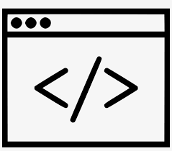 | Other scripting languages | SQL, MATLAB, Java, XML, XSL, UNIX, Stata, Git.
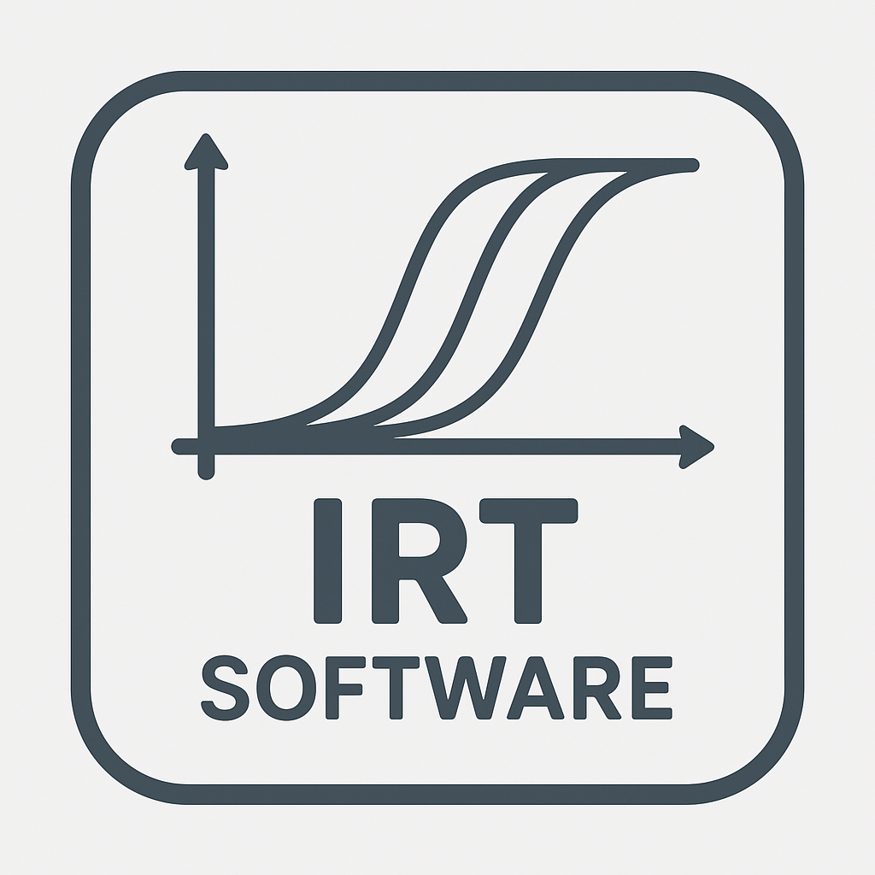 | Psychometric & Statistical Software | FlexMIRT, MPlus.
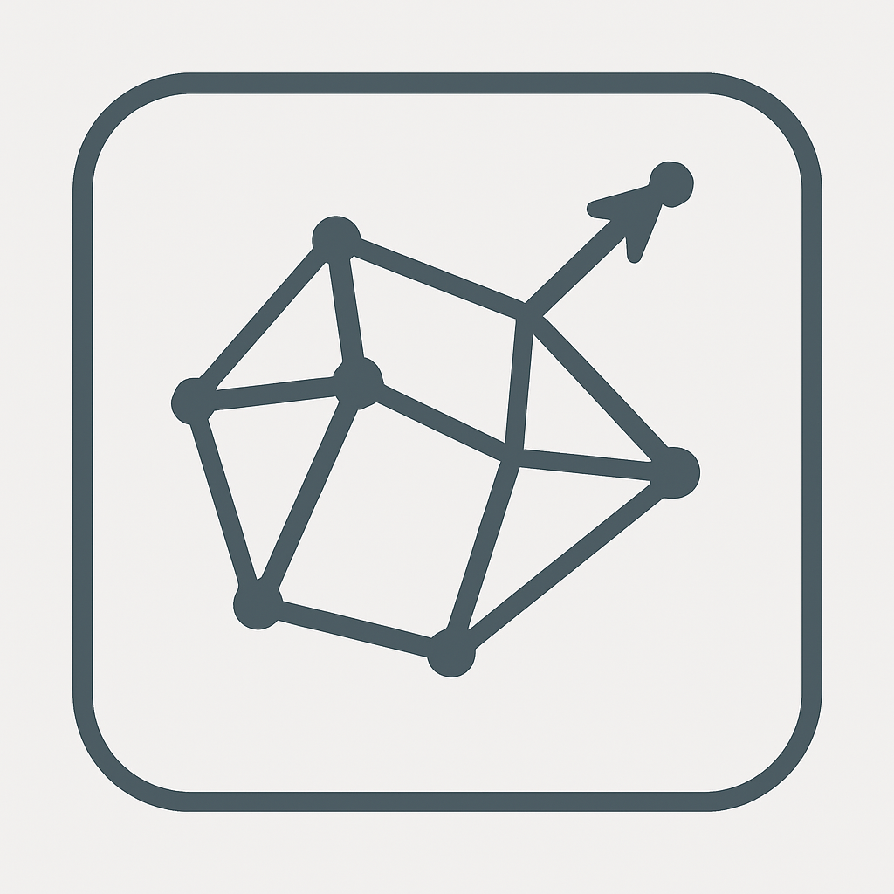 | Optimization Software | Gurobi, Cplex.

 | English | Advanced reading level, Advanced oral level, Advanced writing level. TOEFL iBT score 102/120
 | French | Advanced reading level, Intermediate oral level, Intermediate writing level.
 | Spanish | Native Language.  Chilean Passport.

Other Work Experiences (Education)

Research Scientist, Caveon; July 2023 – June 2026 (3Y)  Remote, done from New York City, NY, US  General work on research topics of relevance for Caveon, including the use of Large Language Models (LLM) in combination with Caveon’s technologies like SmartItems™. Participation in conferences and Collaboration with members of the company doing Research and preparing papers. | 
Associate Psychometrician, College Board; October 2022 – April 2023 (7M)  Remote, done from New York City, NY, US  I participated in the work of the PsyTech Team in the Psychometrics division at College Board. Part of my duties corresponded to Research related to Item Parameter Drift and Automatic Essay Scoring for the SAT Essay test. | 
Research Assistant, Departamento de Medición y Registro Educacional (DEMRE); August 2017 – December 2018 (1Y 4M)  In-person Santiago, Chile; and Remote, done from Jersey City, NJ, US  DEMRE is a department under Universidad de Chile that specializes in educational measurement. It is responsible for designing the Prueba de Selección Universitaria (PSU), the exam used for college admissions in Chile. I worked as a research assistant in a project evaluating the use of one score named “ranking de notas” in the Chilean admission system. | 

Internships (Education)

Caveon, March 2022 – August 2022  Remote, done from Amherst, MA, US  I worked constructing “Smart-items,” a technology developed by the company for Automatic Item Generation. I used my programming skills to create Smart-items of different types. I used Natural Language Processing as well to generate Correct-Incorrect statements automatically from a text. | 
ETS AI Labs, June 2021 – August 2021  Remote, done from Amherst, MA, US  I worked as a summer intern in one of the projects of the AI labs at ETS, an app named “Authentic,” made to help early career professionals to improve their interview skills. My role in the agile team was to provide a logic for feedback generation for audio cues in an interview, specifically using filler words and effective uses of pauses. | 

